2 clothes racks and 10 – 12 med to large boxes
Dining Table and 5 chairs - L 1800mm W 900mm H1000mm
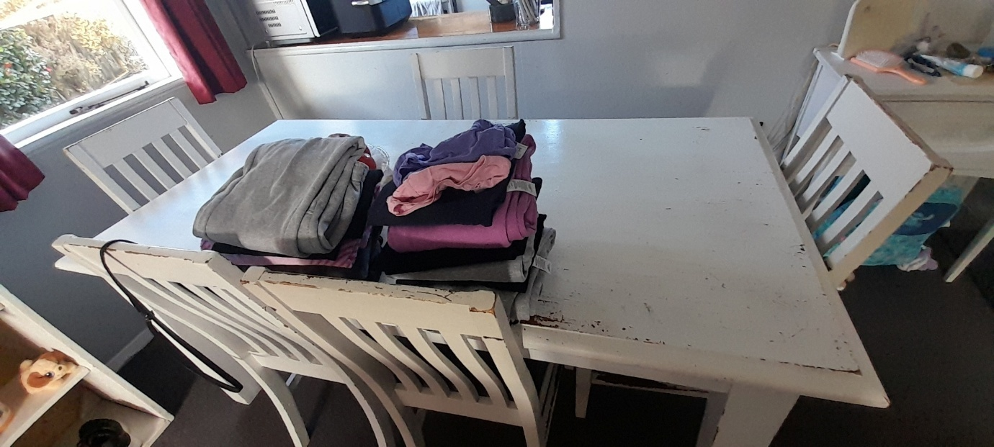

Desk table which will be flat-packed - L 1800mm W 800mm D 250-300mm (when flat-packed)
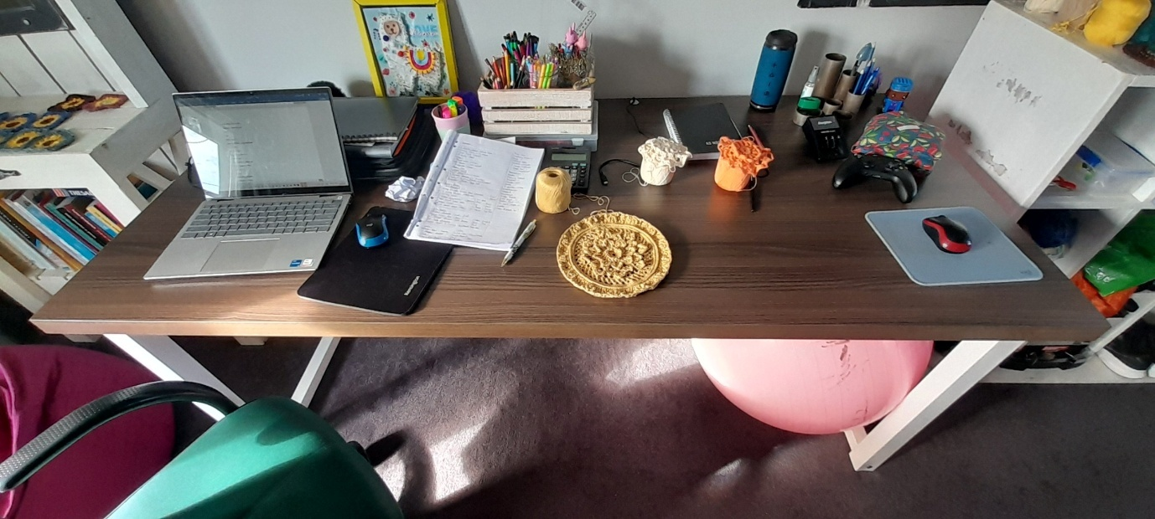

9 Cubby Shelf – D 400mm W 1040mm H1000mm
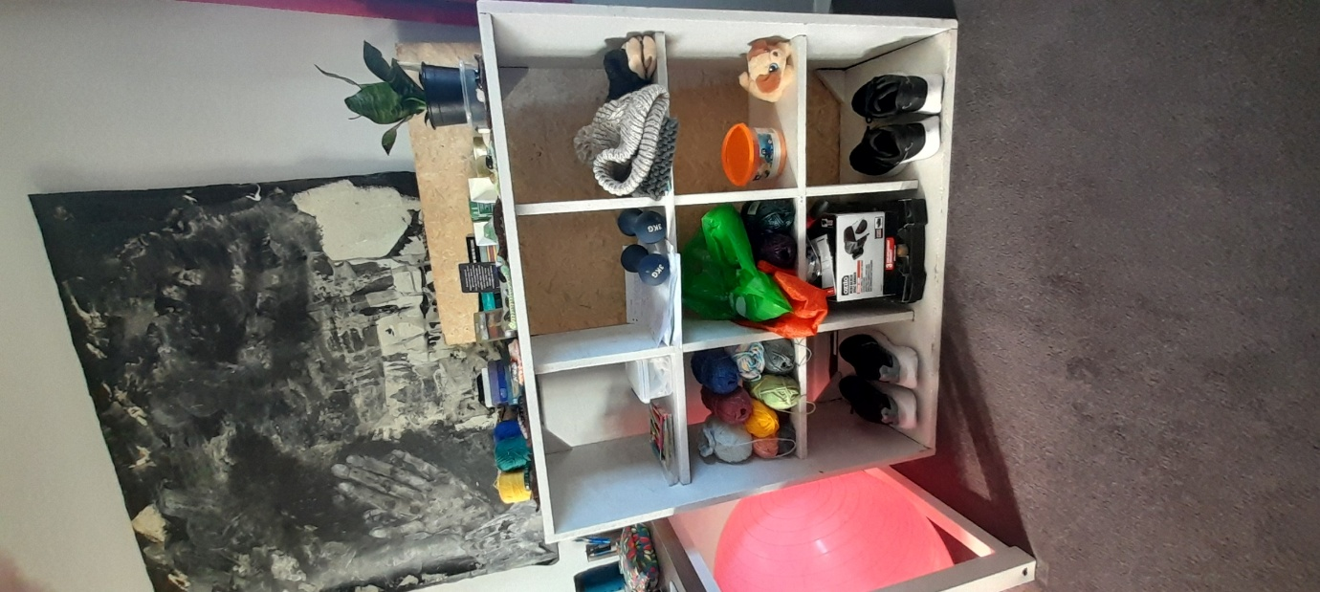

Chest – D 390mm W 120mm H 510mm
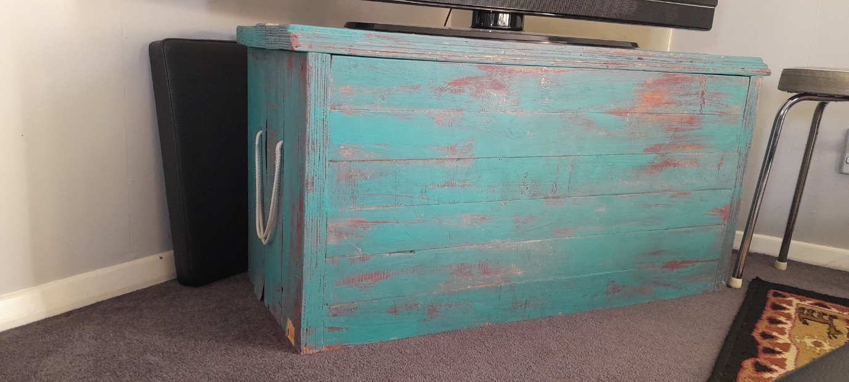

Shelf with mirror – D 340mm W 780mm H 1680mm
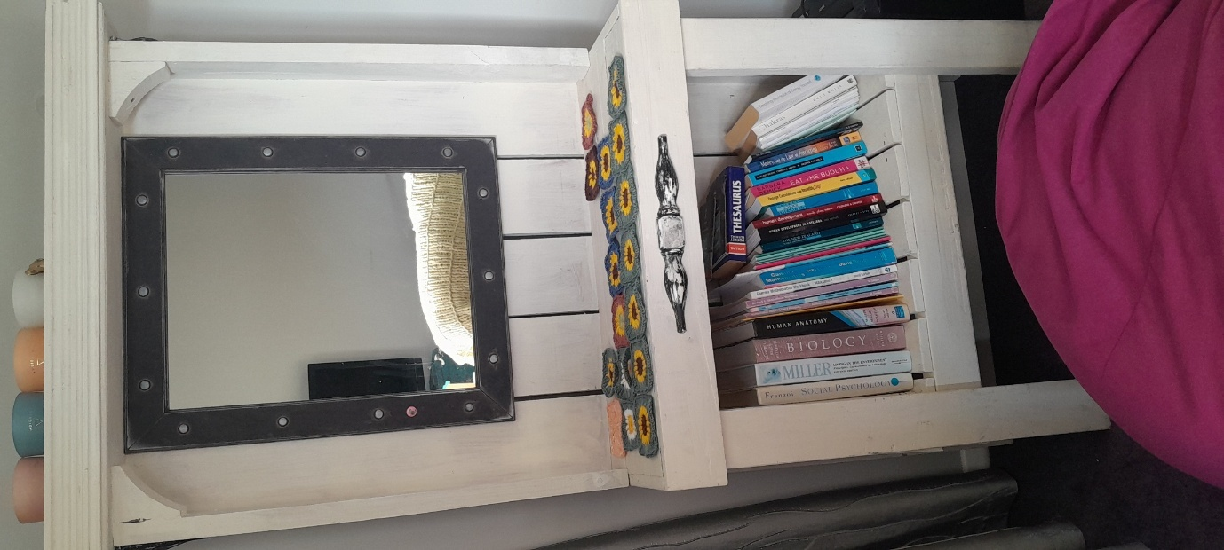

Reformer Pilates Exercise Machine will be folded down flat to half this length and boxed.
W 550mm L 1050mm D 350mm when boxed.
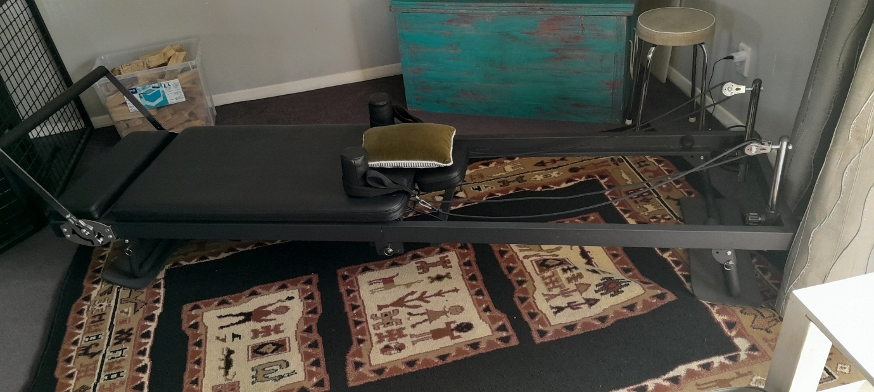

40kg weight set, plastic.
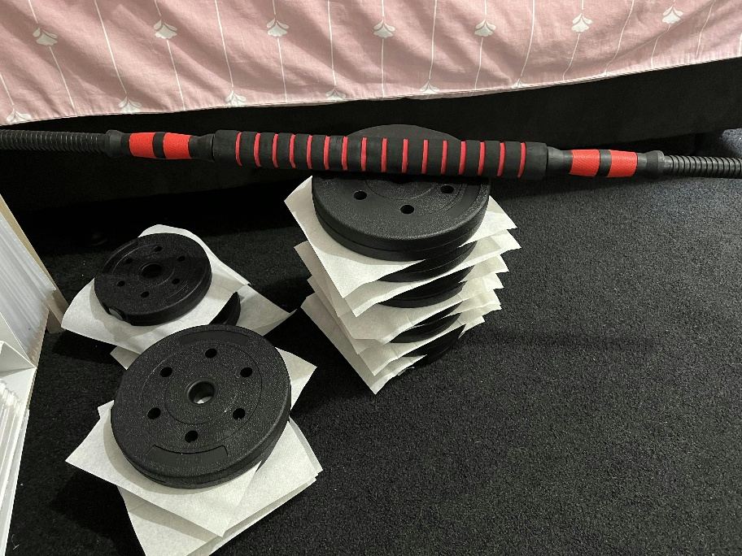

Computer chair – W 600mm H 980mm D 640mm
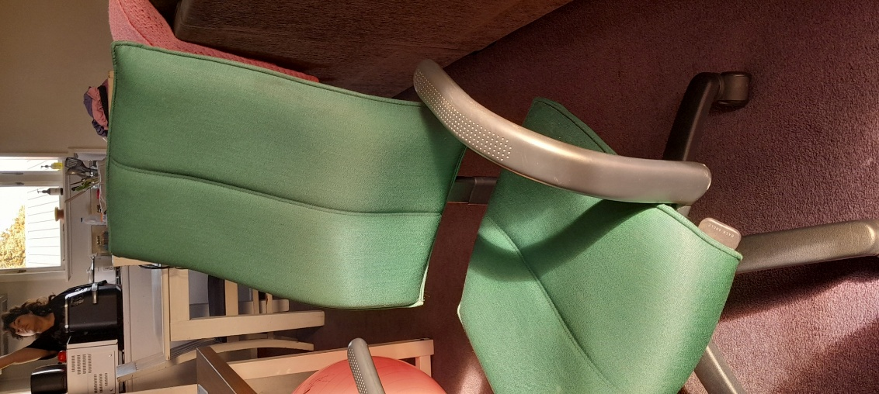

Bean Bag medium size
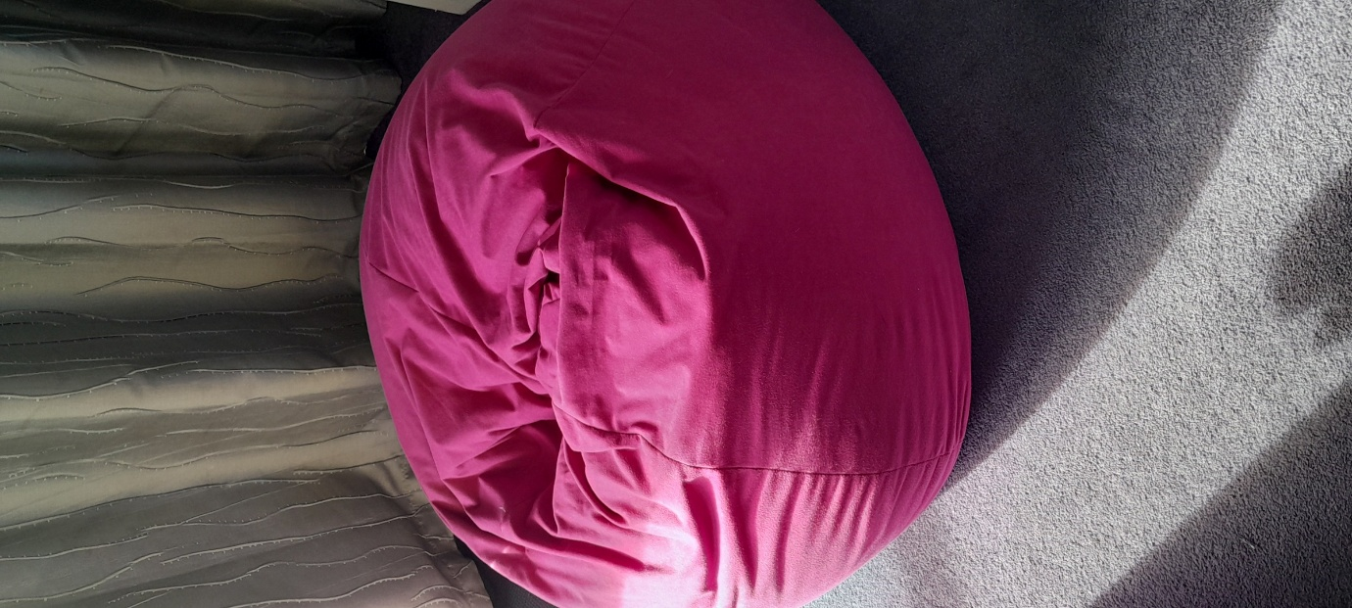

4 Drawer dresser – D 450mm W 790mm H 890mm
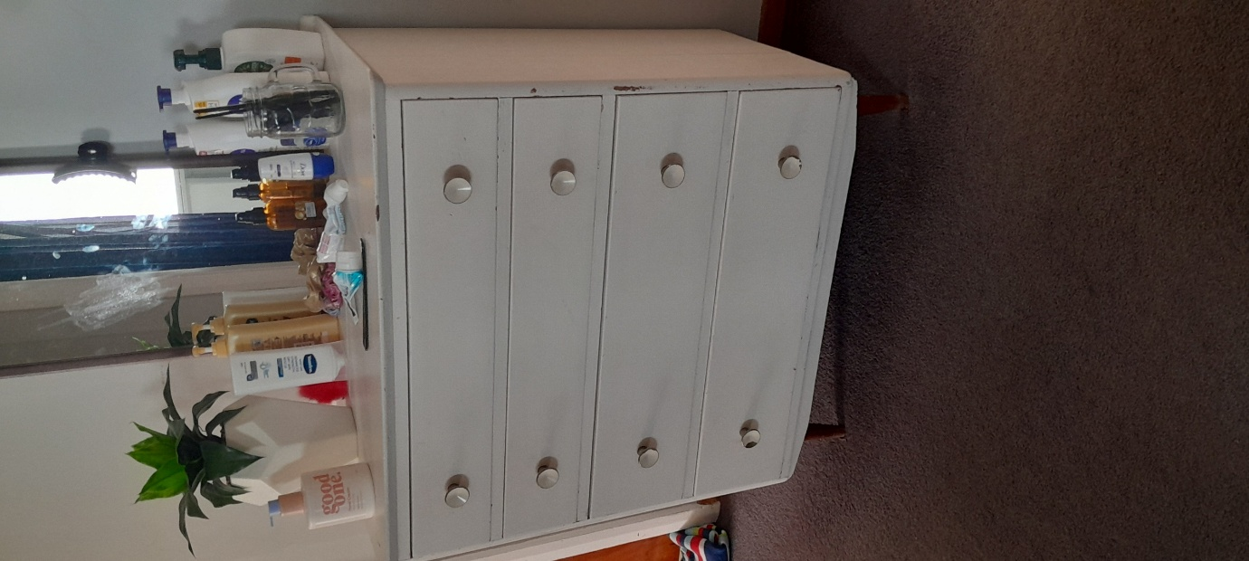

King Single Bunk bed will be dismantled and boxed by me into 4 boxes plus 2 King single mattresses.
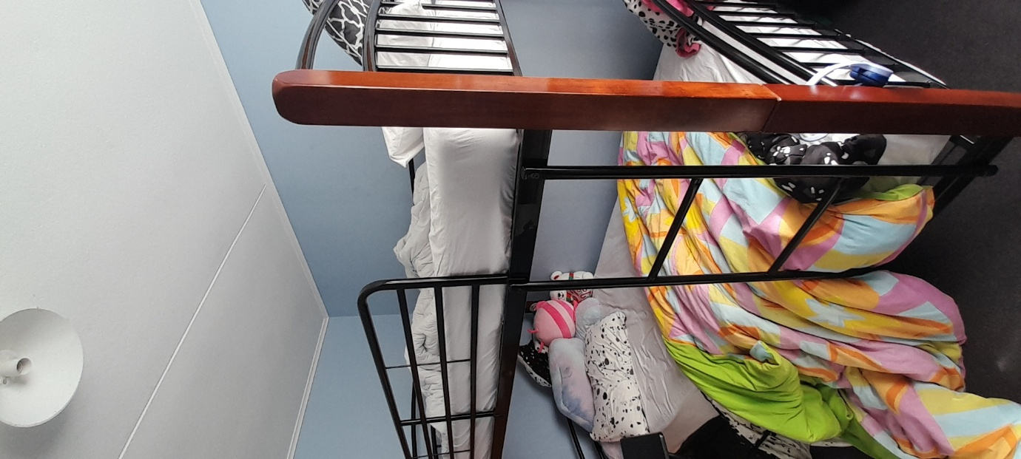

Writing Desk – W 930mm D 360mm H 1025mm
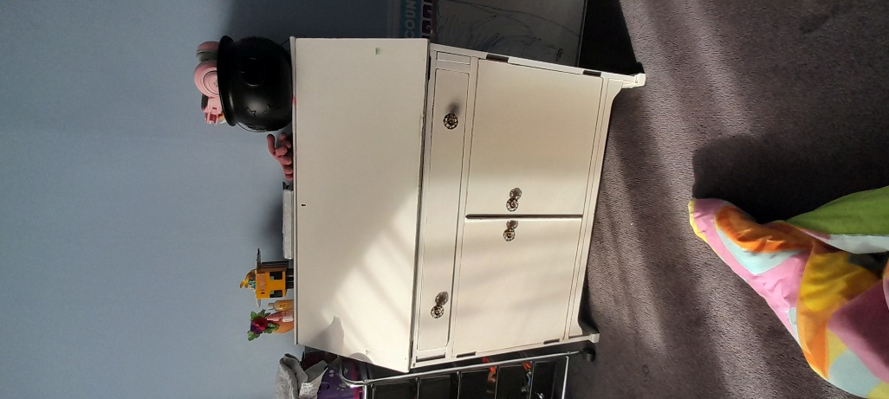

Dresser Cupboard – D 350mm W 1080mm H 1040mm
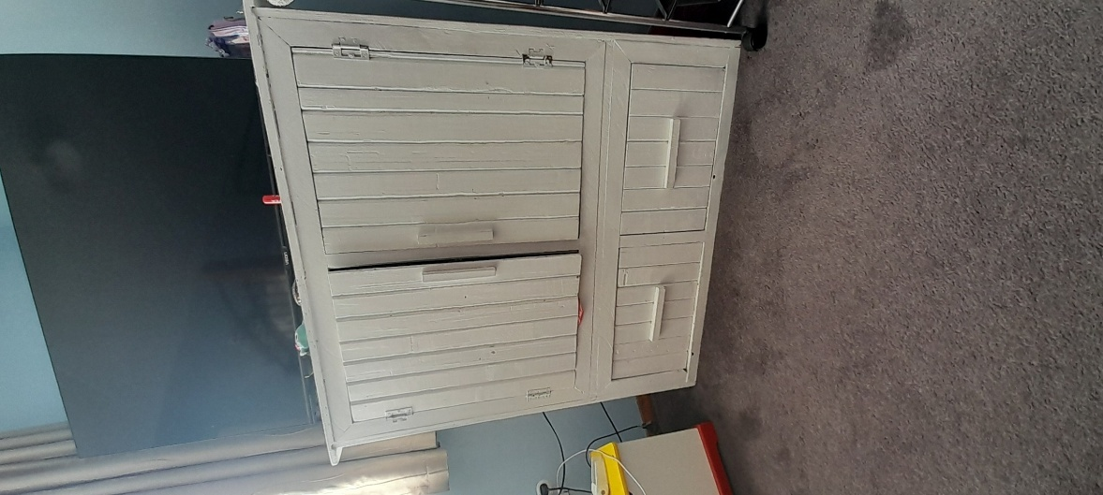

Small fold down table
Med fold down table

x2 Side Drawers – D 440mm W 500mm H 1100mm
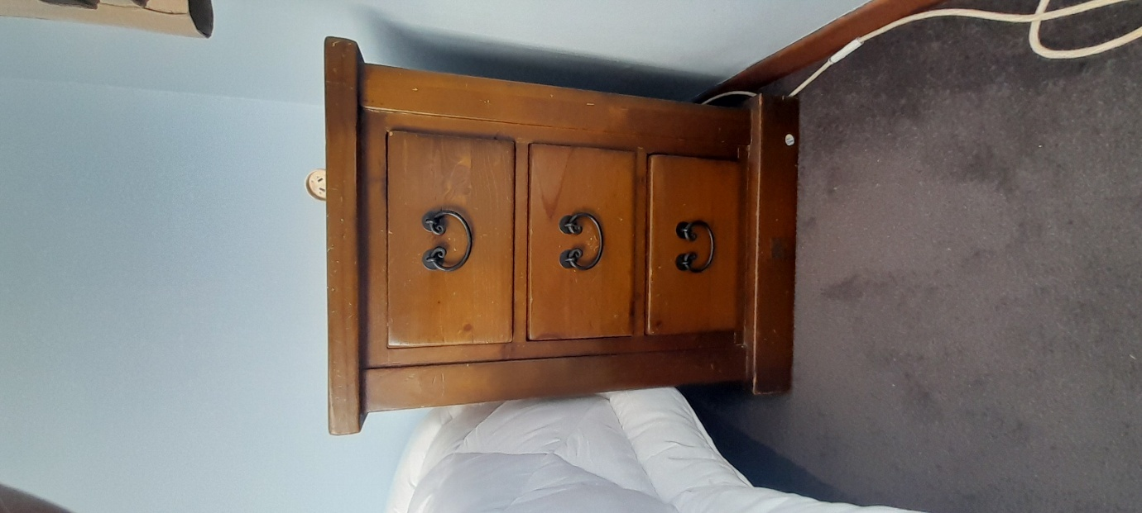

7 drawer dresser – D 440mm W 1400 H 780mm
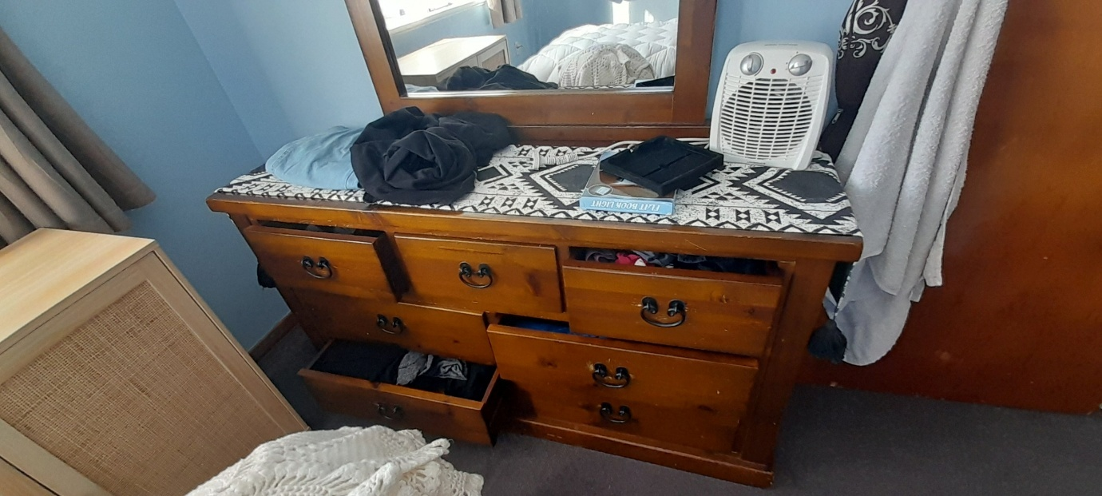

5 drawer dresser – D 440mm W 970mm H 780mm
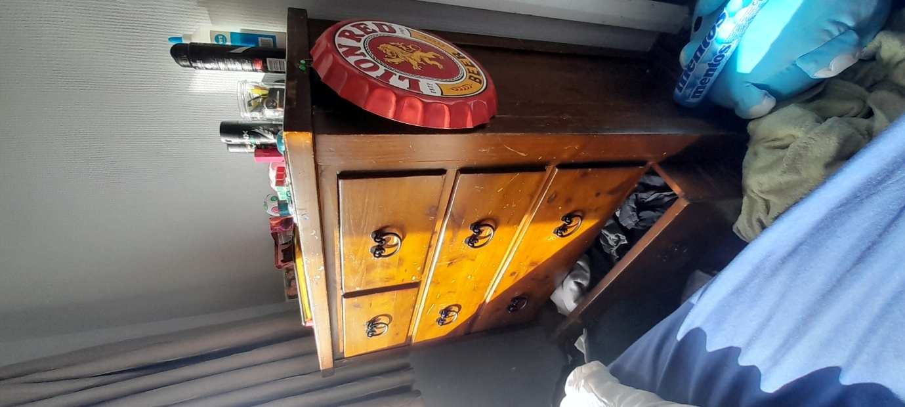

Queen mattress plus headboard and bed frame will be dismantled and boxed by me.
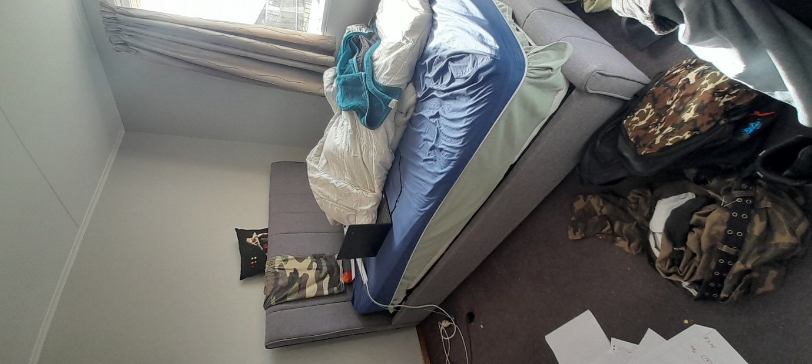
Clothes racks

Large potted container of orchids. D 400mm W 800mm H 350 (height of box).
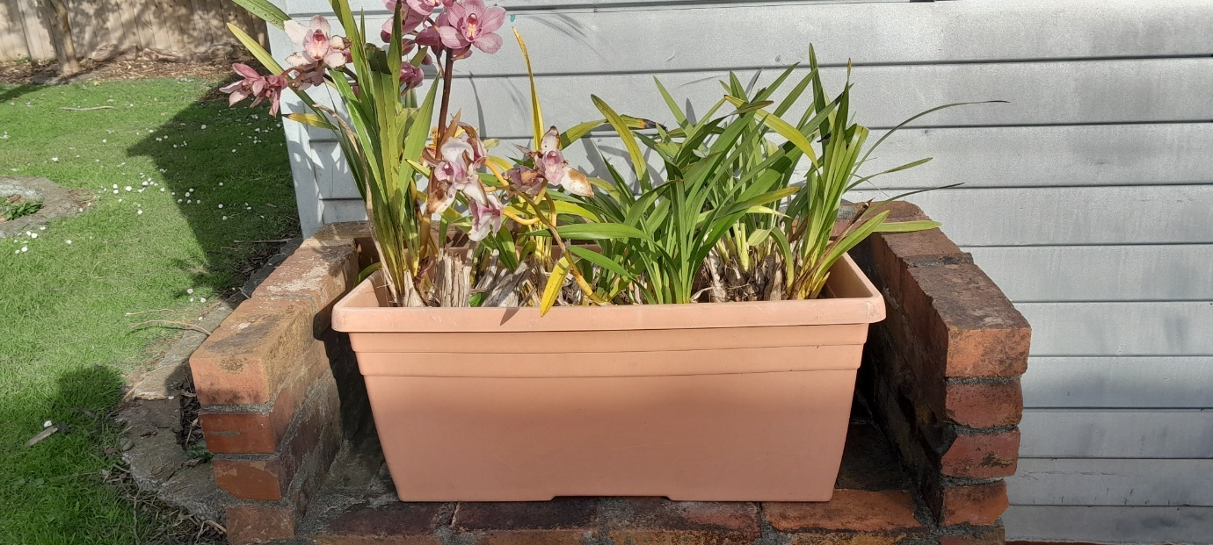

Desk – D 600mm W 1190mm H 760mm
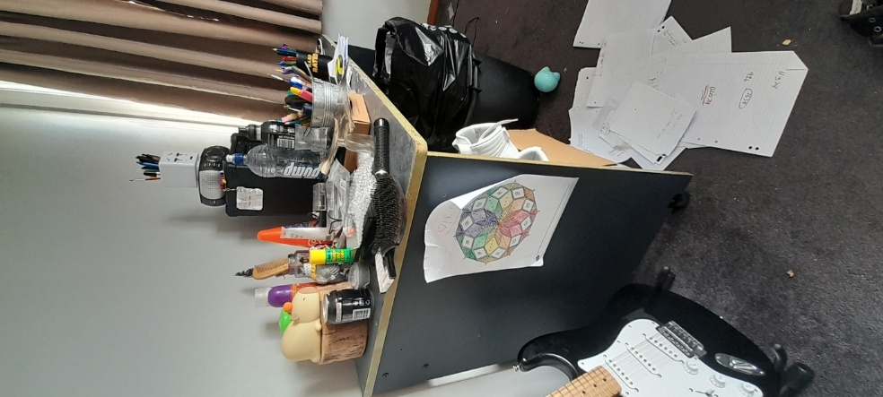

Small cupboard will be dismantled by me and flat-packed. L 800mm W 400 D 230mm (when flatpacked).
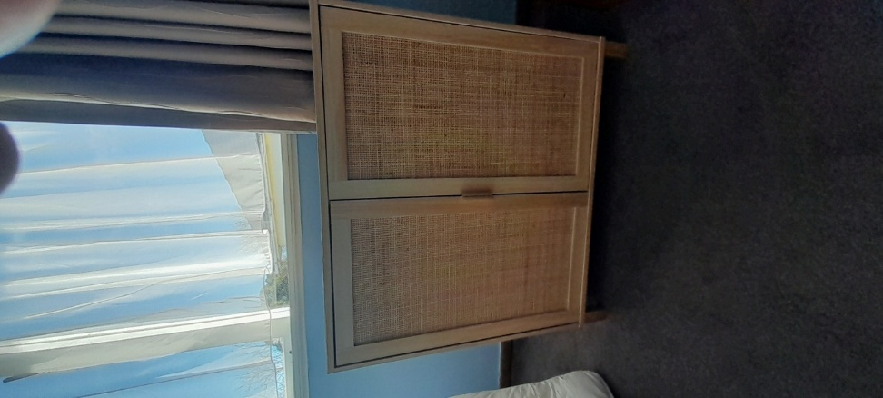

Small cupboard - H 780mm W 660mm D 390mm
